POSITION DESCRIPTION

1. POSITION TITLE: Campaign Officer - Conferences/National Events

2. WORK UNIT: Marketing

3. RESPONSIBLE TO: Commercial Marketing Manager

4. LOCATION: Melbourne, Victoria

5. PURPOSE:
The role of the Campaign Officer is to lead the development and implementation of marketing and communication activities to increase awareness and demand for Engineers Australia’s national conferences and events portfolio.

This role will be required to work collaboratively with a range of internal and external stakeholders to formulate and implement strategies and activities to achieve business objectives and meet stakeholder needs.

6. DUTIES
  - Develop and implement effective marketing campaigns that reference individual conference objectives, target audience, history, and competitor landscape
  - Prepare advanced marketing campaigns for international conferences hosted by Engineers Australia
  - Prepare marketing material for conference and events portfolio on a regular basis. This includes digital and print material
  - Write copy for all marketing collateral relevant to the portfolio
  - Enhance and maintain the conference marketing database
  - Compile research on competitor events to assist in formulating marketing strategies
  - Undertake detailed ongoing analysis of marketing campaigns to ensure targets are met
  - Work with the Social Media Manager to implement social media campaigns for the relevant conferences
  - Develop and regularly update conference and events websites and monitor websites for enhancements
  - Deliver all marketing related benefits as per conference partnership agreements
  - Research promotional partnership opportunities with relevant media and trade associations
  - Research promotional partnership opportunities with related industry conferences
  - All other duties as required

7. OUR VALUES
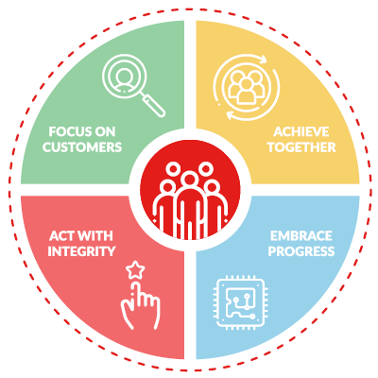

Focus on Customers
we are committed to delivering exceptional products, services and experiences for our members and customers.
We do this by:
- caring about our members and customers, listening to them and seeking to understand their needs
- helping our customers achieve their goals
- providing service excellence
- using our member’s funds prudently and in a sustainable way
Achieve Together
we are at our best when we collaborate and use our collective expertise.
We do this by:
- working inclusively as ‘One Team’ to create a positive and enthusiastic culture
- valuing everyone’s contribution, respecting the uniqueness of individuals
- sharing information and ideas openly and broadly
- encouraging and supporting others to do their best

Embrace Progress
we actively seek out ways to improve through adopting ideas from our colleagues, customers and the world around us.
We do this by:
- staying informed in our ever changing world
- being agile and adopting new and simpler ways of working
- actively coaching, mentoring and encouraging creative thinking
- accepting mistakes can happen and learning from them
Act with Integrity
we earn trust by being authentic and accountable.
We do this by:
- doing the right thing, even when it is not easy
- giving and expecting our best, always
- keeping our promises, saying what we mean and doing as we say
- communicating openly, honestly and respectfully, being mindful of impact

8. COMMUNICATION AND RELATIONSHIPS
- National Manager, Conferences and Events
- National Manager, Marketing
- Commercial Marketing Manager
- Marketing Team
- Conferences and Events Team
- Business Development Team
- Conference Committees
- Engineers Australia members
- Industry partners
- Agencies
- Media providers
- Designers
- Other professional bodies/associations

9. SELECTION CRITERIA
- Demonstrated experience in events marketing, including strategic planning with regards to marketing and communications activity
- Demonstrated experience in building strong, positive relationships and understanding stakeholder needs
- Highly organised, proactive and forward thinker
- Outstanding verbal and written communications skills
- Ability to deal with ambiguity and adapt to changing priorities
- Ability to deliver when working to tight deadlines
- Accountable
- Strong project/time management
- Demonstrated experience working under limited supervision
- Sound commercial experience
- Tertiary qualifications in marketing, communications or related field
- Intermediate skills in Adobe Creative Suite and MS Suite applications
- Salesforce Marketing Cloud and social media experience (desired but not essential)

10. WORK HEALTH & SAFETY (WHS) OBLIGATIONS
As a worker for Engineers Australia, you must:
  - Take reasonable care for your own health and safety in the workplace
  - Take reasonable care that your acts or omissions do not adversely affect the health and safety of others in the workplace
  - Cooperate with your employer about matters of health and safety
  - Comply with any reasonable instruction and cooperate with Engineers Australia’s WHS policies and procedures
  - Familiarise the broad meaning of ‘workplace’ in health and safety legislation and Engineers Australia WHS policies and procedures

