POSITION DESCRIPTION

POSITION TITLE: IT Support Developer

WORK UNIT: Engineering Education Australia

RESPONSIBLE TO: Education Business Systems Analyst

LOCATION: Melbourne, VIC

PURPOSE
Responsible for the effective and timely maintenance and administration of EEA IT systems and user support.

DUTIES
Duties and responsibilities of this position include:
- First and second level IT support.
- LMS administration
- LMS LTI (Learning Tools Interoperability) development
- Webinar technical support
- Ongoing learning applications debugging and maintenance
- Development of backend micro services
- Website maintenance and development
- Creating reports from different systems
- Software installation and maintenance.
- Other IT duties as required.

WORK HEALTH & SAFETY (WHS) OBLIGATIONS
As an employee of Engineering Education Australia, you must always:
- Take reasonable care for your own health and safety in the workplace.
- Take reasonable care that your acts or omissions do not adversely affect the health and safety of others in the workplace.
- Cooperate with your employer about matters of health and safety.
- Comply with any reasonable instruction and cooperate with Engineering Education Australia’s WHS policies and procedures.
- Familiarise with the broad meaning of ‘workplace’ in health and safety legislation and Engineering Education Australia’s WHS policies and procedures.

COMMUNICATION AND RELATIONSHIPS
This position works closely with Engineering Education Australia and Engineers Australia staff as well as a broad range of external stakeholders, particularly across engineering organisations.

OUR VALUES
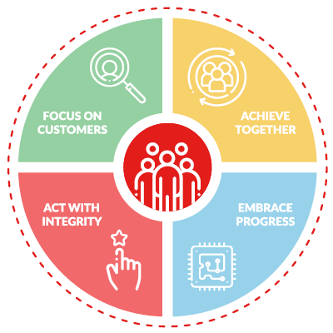

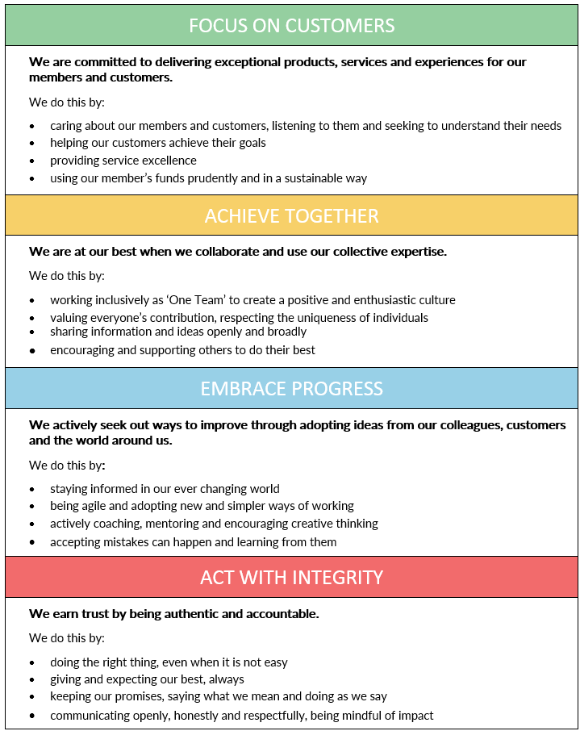

SELECTION CRITERIA
- Tertiary qualification in Information Technology or related discipline (highly desirable).
- 3+ years’ experience working in IT support,
- Exposure to corporate training, VET competency-based training, and online learning (desirable).
- Experience in LTI (Learning Tools Interoperability) development within LMS systems
- Proficient in PHP and JavaScript development
- Strong understanding of MySQL databases
- Experience with administering and supporting learning management systems (Canvas desirable), rapid authoring tools, such as Articulate Storyline or Rise, and multimedia development applications.
- Exposure to CMS systems for websites (preferably Drupal)
- An ability to understand and regularly adopt up-to-date technology and techniques and stay abreast of emerging trends and industry best practice.
- Excellent written and verbal communication skills, with high attention to detail.
- Ability to manage own time effectively, to work calmly and assuredly on multiple projects at a time.
- Ability to work autonomously and in a collaborative team environment.
- Ability to maintain a positive and flexible approach whilst working with multiple stakeholders.
- Exposure to the education industry would be beneficial.
- An ability to travel within Australia, on occasion, as required.

