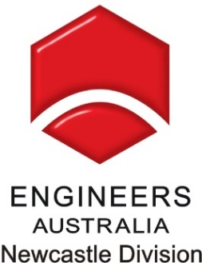

Newcastle Division

Electrical Branch Program 2017

* The following table outlines the 2017 program as it stands on 01/01/2017.

Date | Topic
8th Feb | The Story behind the Changes to the HV Installation Design Standard (AS2067) part 1
8th Mar | The Story behind the Changes to the HV Installation Design Standard (AS2067) part 2
13th Apr | Australia as an Energy Super Power – What would it take to be 100% renewable
10th May | Science Fiction to Reality in Autonomous Technologies
15th Jun | Smart Grids Half Day Tutorial – 3pm-7pm. Venue TBC
12th Jul | Electric Vehicles – Do they benefit or destroy the grid?
9th Aug | Using Old Mines as Energy Storage
9th Sep | What it’ like to Work in Big Data – a software engineer’s view
14th Oct | Identification of High risk Distribution Assets by Assessment and Test
11th Nov | TBA – incorporating Annual Meeting

Events to be held in Engineers Australia Auditorium with webinar to be offered (subject to agreement by speaker/s). Exception potentially being Half day Tutorial on 15 June as venue for that event is ‘To Be Confirmed.’

If you have any questions or suggestions please contact
Olsen Garland (Electrical Branch Chair) on 0411 544 066

2016 Committee Members
Olsen Garland (Chair) | Ron Scollay (ECB Rep) | Jemima Jackson Brendan Noake
Paul Russell (EESA Rep) | Peter Cockbain (Patron) | Bill Carman
Brad Driscoll | Tim de Grauw | Terry Summers

