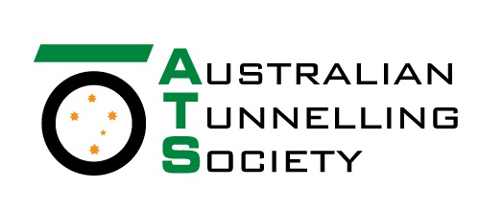
Victorian Group
Chair Richard Buckingham
Contact Anthony Bennett
Telephone - BH 0412 529 028
Web – www.ats.org.au

“Sprayed Concrete Linings: Design and Application”
Tuesday 16th April 2019

Dr Alun Thomas, All2plan Consulting ApS

Precis of talk:

Sprayed concrete linings (SCL) are increasingly popular in both rock and soft ground. Recent years have seen a shift towards permanent sprayed concrete linings, the use of fibre reinforcement and even composite shell linings with spray applied waterproofing membranes. The use of SCL in sensitive urban environments has led to the wider use of numerical models to demonstrate the safety of this method and to develop designs. This talk will review current best practice in Europe and elsewhere and look forward to future developments which will make SCL tunnels both more cost effective and sustainable.

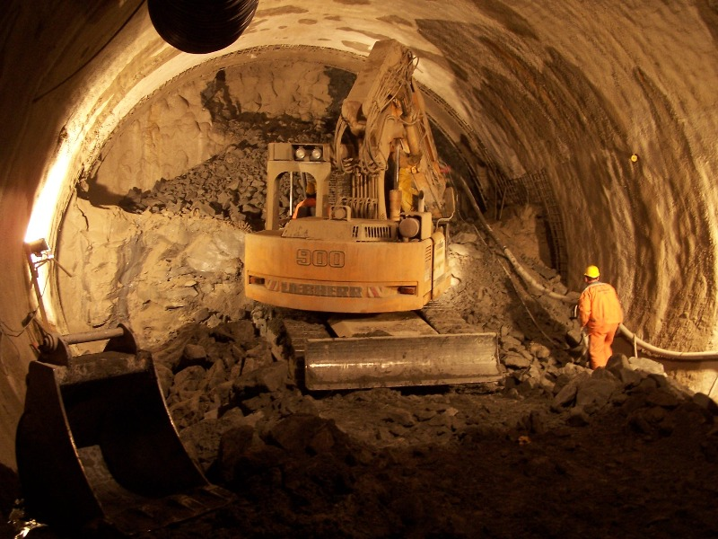
About Alun Thomas:

Dr Thomas has a broad experience of many types of tunnelling methods from immersed tubes to segmental linings, from closed face TBMs to hand excavation under compressed air. He is a specialist in sprayed concrete lined (SCL/NATM) tunnels and numerical modelling. He has been involved in promoting the use of permanent sprayed concrete, fibre reinforcement and spray-applied waterproof membranes. A regular contributor to magazines and conferences, he has written articles on subjects ranging from sustainability to user-friendly contracts. His book, “Sprayed concrete lined tunnels”, has been published in English, Chinese and Turkish. The second edition is under preparation. Dr Thomas is a member of the ITA’s Working Group 12 on Sprayed Concrete. He has also been active in ITAtech groups and he is currently working on the update of the ITAtech guidance on Spray Applied Waterproofing Membranes.

Time: Commencing at 6pm (with refreshments at 5.30pm)
Where: Engineers Australia, Level 31, 600 Bourke St, Melbourne
Cost: Free for members (Please register at EA Victorian Division’s events page)
 | Session sponsored by | Session Contact: Michal Fronek  e-mail : michal.fronek@wgtp.com.au
Engineers Australia members participating in ATS technical sessions can record attendance on their personal CPD logs. Members should refer to Engineers Australia CPD policy for details on CPD types, requirements and auditing guidelines.

