The Challenge of Technological Capability Imbalance: Strategic Perspectives for Emerging Economies
by Dr K. Ramanathan, BSc (Eng) Hons., MEng, PhD
Wednesday 17th of April 2019
Engineers Australia (8 Thomas St, Chatswood NSW 2067
Please arrive at 5.30 pm for 6.00pm start
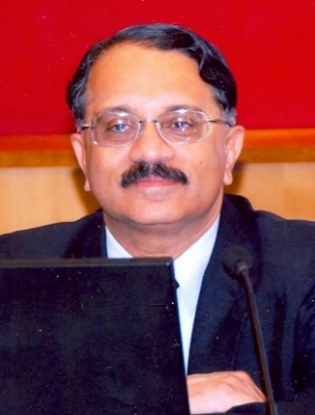
Dr K. Ramanathan,
BSc (Eng) Hons, MEng, PhD
Former Head of the United Nations – ESCAP Asian and Pacific
Centre for Transfer of Technology (UNESCAP-APCTT)

Dr Rama K. Ramanathan retired in late 2012, as the Director/Head of the United Nations ESCAP - Asian an d Pacific Centre for Transfer of Technology (UN-APCTT). Prior to becoming Head of UN-APCTT in 2006, he was with the Business Systems program at the School of Management of the University of Western Sydney from 1997 – 2006. From 1989 - 1997, he was Associate Professor at the School of Management of the Asian Institute of Technology, Bangkok, Thailand where he helped design and run the MBA and Ph.D. programs in management of technology. He started his professional life in 1973, in Sri Lanka, as a mechanical engineer on the shop floor. He later joined the National Institute of Business Management (NIBM), Sri Lanka, where he worked till 1986 as Senior Management Consultant and headed their Division of Industrial Engineering. From 1986 – 1989, he undertook a three-year stint with the United Nations, as Expert in Technology Management in the ‘Technology Atlas Project’ funded by the Government of Japan. Over the past three decades, he has undertaken capacity building, research and consulting assignments in operations and technology management for several United Nations agencies, the Asian Development Bank, the European Commission DG XII, the Economic Research Institute for ASEAN and East Asia, and the Ministries of Science and Technology of several governments in the Asia-Pacific region. He is presently a Consultant in Management of Technology and Innovation and is based in Sydney. In addition to his international consulting work he teaches on the MBA programs at the Sydney campuses of the Western Sydney University and the S.P. Jain School of Global Management. He has published in prestigious academic journals, contributed to book chapters, and has supervised the research of over 60 MBA and PhD students.

The Challenge of Technological Capability Imbalance: Strategic Perspectives for Emerging Economies
Emerging economies must manage their development in the context of a world economy that, as pointed in the Global Competitiveness Report (2018), is evolving in the midst of rapid technological change, uneven distribution of the benefits of economic progress, generational divides, rising income inequality in advanced economies, increasing environmental degradation, political polarization and a fragile economic recovery. Yet, there is optimism that technological advancement and the diffusion of critical technologies such as information and communication technologies can generate a wave of innovations that can lead to the development of new business models and drive longer-term growth. Yet, there are several multi-dimensional and interrelated challenges that can slow down the march towards sustainable prosperity. Addressing these challenges should thus be the core of a strategic development vision for the Asia-Pacific, especially the emerging economies in the region. One of the major challenges, among others, is reducing ‘technological capacity imbalance’ to promote innovative behaviour and fuller participation of national enterprises, especially small and medium enterprises, in economic activities so that they can integrate more effectively with global markets.

The focus of this presentation will therefore be on four critical areas that emerging economies in the Asia-Pacific region need to address to reduce technological capacity imbalance. The first is ‘developing capacity for knowledge management’ since experience suggests that organizations that manage their knowledge assets effectively find it easier to upgrade their technological capabilities. The second is, ‘developing the capacity to green the supply chain’ since it is now accepted that to achieve high-performing value systems and sustainable competitive advantage (SCA), supply chain management (SCM) must necessarily incorporate both energy and environmental dimensions. Thirdly, ‘developing the capacity to innovate innovation’ becomes imperative in a setting where research and development (R&D) collaboration across borders has intensified and is likely to become the norm. Lastly, ‘developing the capacity to become a vital partner in an Industry 4.0 setting’ becomes important as ‘reshoring’ in technologically advanced high labour cost nations is returning jobs that had previously been exported to low labour cost developing and emerging economies.

It is imperative that emerging economies address these four critical areas with a sense of urgency since the continued existence and deepening of technological capacity imbalance will only perpetuate technological backwardness and delay development. It also has the potential to create distrust between the technologically advanced nations and those less advanced. There are no easy solutions. Yet, the destinies of the ‘haves’ are intrinsically linked to the fates of the ‘have littles’ and the ‘have-nothing-at-alls.’ Innovative approaches thus need to be ‘imagineered’ and implemented collaboratively by governments, the private sector, and indeed the community, in emerging nations to correct this technology capability imbalance so that sustainable, long-term growth becomes feasible.

