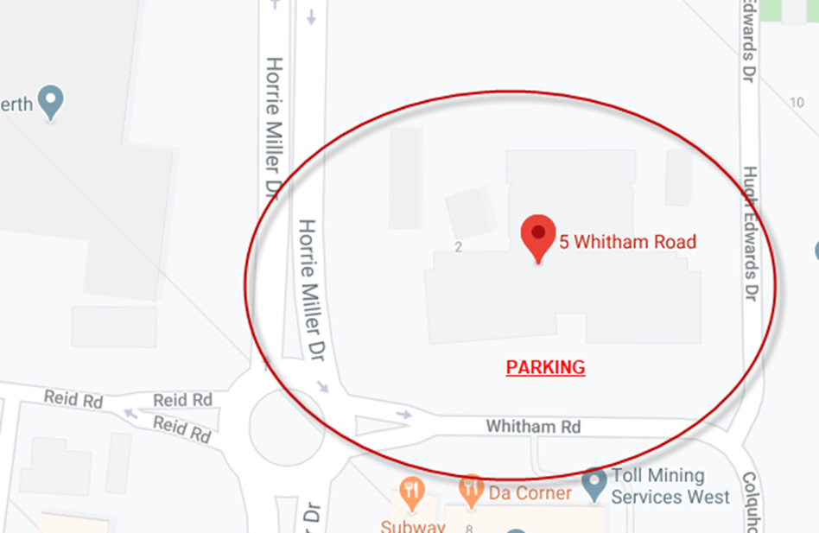

Date: Saturday 21st March 2020
Time: 09:30 to 12:00
Venue Address: 5 Whitham Road Perth Airport WA 6105-Reception area

