IESL NSW Chapter Women in Engineering Day
Thursday 28th of March 2019
Engineers Australia (8 Thomas St, Chatswood NSW 2067)
Please arrive at 5.00 pm for 5.30pm start

Register

The New South Wales (NSW) Chapter of Institution of Engineers Sri Lanka (IESL) invites you to attend The Women in Engineering (WiE) day. The speakers will share their experiences of being an engineer and the path navigated during their career.
This will be a valuable opportunity to: Hear from Women in Engineering leadership; Network with a diverse group of women committed in supporting and promoting women in engineering,
WiE day will feature the inaugural speech by Dr Marlene Kanga, President of the World Federation of Engineering Organisations and thirteen other speakers from industry and academia. The evening is sure to be an inspiring and a wonderful celebration of women in engineering. As a group, we will be inspired by diverse personalities, creativity and unique approach women offer not only to the engineering industry but to the community. We acknowledge the important role of women in the society and this forum hopes to create a platform to inspire young women to pursue a career in engineering.
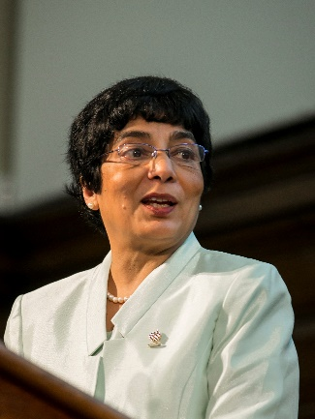
Dr Marlene Kanga, AM, Hon. FIEAust, Hon. FIChemE, FTSE
President of the World Federation of Engineering Organisations
Dr Kanga is a chemical engineer, specialising in process safety risk engineering and an Honorary Fellow of the Institution of Engineers Australia, Honorary Fellow of the Institution of Chemical Engineers (UK). She is also a Fellow of the Academy of Technology and Engineering (Australia), a Foreign Fellow of the ASEAN Academy of Engineering and Technology and Fellow of the Australian Institute of Company Directors. Dr Kanga is the 2018 Engineers Australia Professional Engineer of the Year and has been listed among the Top 100 Women of Influence in Australia and the Top 100 Engineers in Australia. She is a Member of the Order of Australia, a national honour, as recognition of her leadership of the engineering profession.
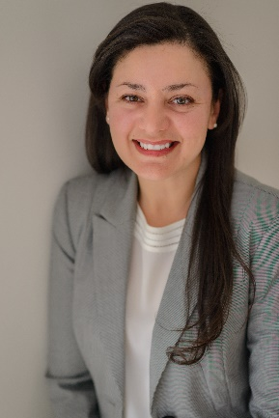
Julie Mikhail, BEng, MEngSc, FIEAust, CPEng, EngExec, NER
Managing Director Engineering Business Pty Ltd,
Immediate Past President of Engineers Australia Sydney Division
Julie, founder of Engineering Business Pty Ltd, is an engineer with more than 17 years' experience in the public sector working on Defence projects including major acquisitions and long-term sustainment contracts. While working for Defence, Julie managed the sustainment (asset management) of Navy’s communication systems. As a result of outstanding management and leadership Julie was awarded a CEO Commendation and the Australia Day Medallion in 2009. Julie also is actively involved with Engineers Australia (EA), and currently holds the position of Immediate Past President of Engineers Australia Sydney Division. Julie holds a Bachelor's Degree in Chemical Engineering, Master's Degree in Engineering Science (Electrical Engineering), a Certificate IV in Government Procurement and is a Fellow and Chartered Engineer of Engineers Australia.

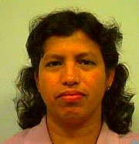
Rajanthi Ravindra, BscEng(Hons), CPEng
Senior Bridge Engineer for New Design at Bridge and Structural Engineering, Roads and Maritime Services
Rajanthi is a chartered professional civil/structural Engineer with over 30 years’ experience in Australia and overseas in the design, construction and maintenance of infrastructure assets from cradle to grave. She graduated from the University of Sri Lanka, Peradeniya - one of the 10 female graduate engineers from a class of 150. She started her career with State Engineering Corporation of Sri Lanka. She moved to Singapore, where she was engaged in the design of medium rise commercial and residential buildings and aerial viaducts for Singapore Mass Rapid Transit (MRT). When she migrated to Sydney, she initially joined Meinhart and Partners and was involved in the design of World Square Gardens, Centennial Plaza buildings in Sydney CBD and industrial buildings. She is currently leading the New Design unit at Bridge and Structural Engineering Division at RMS to prepare the technical briefs, standards and peer review required for the external bridge and structures designs in the delivery of major motorway projects such as WestConnex, Pacific highway and Princes highway projects.
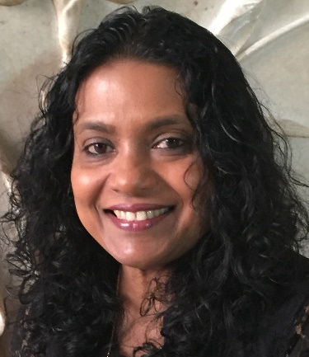
Maya Amaraweera, BScEng(Hons), MEng, MIEAust, CPEng NER, AMIESL
Roadside Asset Manager, Asset Maintenance Planning, Roads and Maritime Services; Past Chair and Committee Member IESL NSW Chapter
Maya has more than 25 years of experience in delivering road infrastructure projects and managing large road networks in Sydney. She has more than 15 years in Leadership roles at RTA/RMS with extensive experience in systems development, design, data modelling and system integration. Maya has an Honours degree in Civil Engineering from the University of Peradeniya, Sri Lanka and a MEng from the Asian Institute of Technology, Thailand. In her current role as the Roadside Asset Manager, Asset Maintenance Planning, Maya manages and coordinates the development and improvement of roadside asset management needs, specifications and systems which enable strategic asset management and risk management of roadside assets in NSW. In 2009 Maya was one of the founding members of establishing the first ever overseas chapter of the Institution of Engineers Sri Lanka in NSW (IESL NSW) and in 2011 served as the Chair of the IESL NSW Chapter.
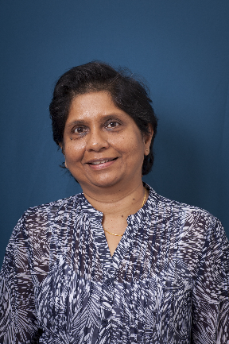
Dr Samanthika Liyanapathirana, BScEng(Hons), PhD
Associate Professor – Civil Engineering, Engineering and Construction Management, Western Sydney University
Samanthika completed her BScEng (Hons) at the University of Moratuwa in 1991, PhD at the University of Western Australia in 1999. From 1999-2003, she worked as a Postdoctoral Fellow at the Centre for Geotechnical Research at the University of Sydney. In 2003, she joined the University of Wollongong as a Lecturer and was promoted to Senior Lecturer in 2005. Currently she is an Associate Professor at the Western Sydney University. She is the recipient of Thomas A. Middlebrooks Award from the ASCE (2007), University of Wollongong Vice Chancellor's Award for outstanding contribution for Teaching and Learning (2008), Australian Geomechanics Award for research carried out on geosynthetic reinforced deep cement mixed column supported embankments (2013), Outstanding Reviewer Award from Elsevier for the journal Computers and Geotechnics (2015). She has served as an editorial member of international journals.
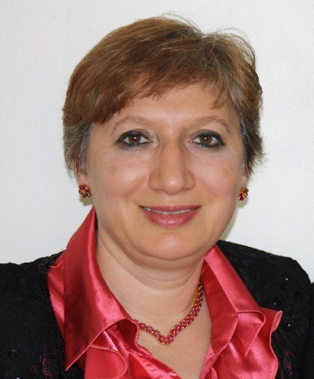
Julia Ratnayake, BEng, MScEng, CPEng, FIEAust
Asset/Strategic Infrastructure Manager, Sydney Planning, Sydney Division, Roads and Maritime Services
Co-Deputy Chairman, Sydney Division Committee, Engineers Australia
Julia has a Bachelor of Mechanical Engineering and a Masters in Industrial Automation Engineering. She is a Project Manager with over 25 years engineering experience in managing a diverse range of Service Delivery, Critical Infrastructure & Business-improvement projects on Manufacturing Industries, Industrial Automation field and NSW Government sector. She is a strong supporter of engineering innovations and implementation of new technologies, and she feels very fortunate to have worked closely with highly skilled research and development teams around the world, specifically in the Industrial Automation field, and to have contributed with new ideas, and even seen some of them realised. Julia is actively involved with Engineers Australia, Sydney Division Committee, as an elected member since 2014. She is currently a Co-Deputy Chairman for the Sydney Division Committee.

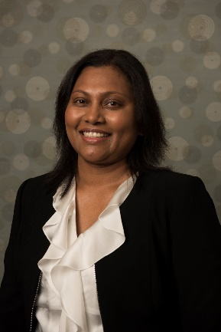
Amali Wickramasinghe, BScEng(Hons), PGDip, CPEng, FIEAust, MIESL, PMP
Underground Mains Engineer, Asset Management, Endeavour Energy
Past Secretary and Committee Member IESL NSW Chapter
Amali Wickramasinghe obtained her BScEng (Hons) in Electrical Engineering in 2001 and PG diploma in Energy Technology in 2005 from the University of Moratuwa. Amali is a fellow (FIEAust) and charted professional Engineer (CPEng) of Engineers Australia and a corporate member of Institution of Engineers Sri Lanka (MIESL). She is a Project Management Professional (PMP) of Project Management Institute, USA. Amali has over 15 years of experience in the Electricity Supply Industry attached to Electricity Utilities in both Australia and Sri Lanka. She has widespread experience in design, construction project management and asset management of Electricity Assets. Amali has a true passion in promoting and mentoring females for STEM learning and engineering roles. She worked with Institution of Engineers Sri Lanka (IESL), Sri Lankan Energy Managers Association (SLEMA), IESL NSW Chapter and Engineers Australia by serving in committees or involving in their programs on a voluntary basis.
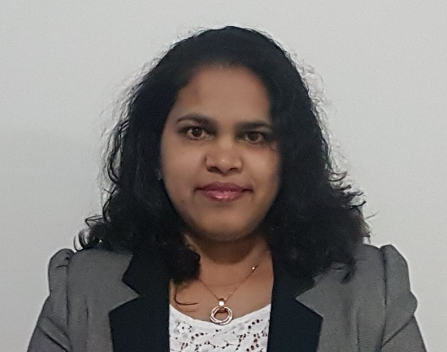
Dr Sujeewa De Silva, BScEng(Hons), GradCert, PhD
Lecturer, School of Physics and Advanced Materials, University of Technology Sydney
Sujeewa received her BScEng in Materials Engineering from the University of Moratuwa, Sri Lanka in 2003. She worked in the industry then joined the department of Materials Science, University of Moratuwa as a lecturer in 2005. She obtained her PhD from University of Wollongong. She completed Graduate Certificate in Higher Education Teaching and Learning from University of Technology Sydney in 2017. She worked as a Research Associate at Institute for Superconducting and Electronic Materials (ISEM), University of Wollongong. She joined the School of Physics & Advanced Materials at University of Technology Sydney (UTS) in January 2014 as a postdoctoral fellow. She has published a book based on her PhD study area and 19 research papers in reputed journals and currently she is working as a lecturer at the UTS.
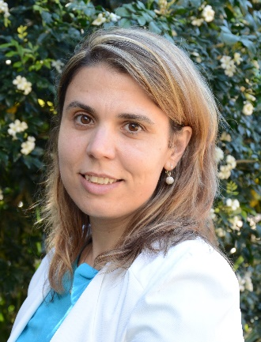
Dr Ana Heitor, BEng, MEng, PhD
Senior Lecturer, School of Civil, Mining & Env Engineering, Faculty of Engineering and Information Sciences, University of Wollongong
Ana received a Licentiate degree in 2004, MEng (Kyoto University, 2009) and PhD (University of Wollongong, 2013) in Geotechnical Engineering. From 2004 to 2006 she worked in consultancy & construction companies in Portugal. She joined the University of Wollongong as a lecturer in 2013 and was promoted as a senior lecturer in 2017. She was honoured in the Young Geotechnical Professional Competition in 2010 & with the AGS NSW Research Student Award in 2012. Her achievements both in research & teaching have been recognized in 2016 UoW Women of Impact and by the John Carter Award for Young Professionals in 2017. In addition, Ana secured two editorial board member positions on Soils & Foundations and Environmental Geotechnics Journals. Her research work is showcased in a number of scholarly academic publications, including international journals & conference proceedings.
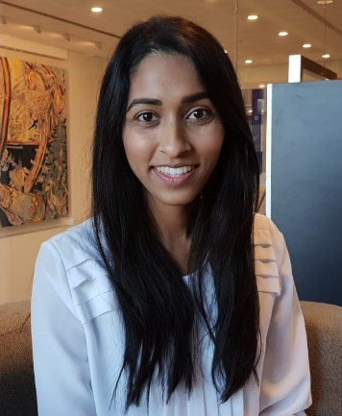
Varuni Fernando, BEng
Senior Systems Engineer at ResMed Ltd,
Immediate Past Chair, Women in Engineering, Engineers Australia Sydney Division, Committee Member, Engineers Australia Sydney Division
Varuni is a Senior Systems Engineer at ResMed Ltd, working on the next generation of devices for the treatment of Sleep Disordered Breathing (SDB). She completed her bachelor degree in Electrical Engineering at the UNSW. She is currently pursuing a Masters in Systems Engineering from Johns Hopkins University. Varuni has had a passion for increasing the number of women in the engineering industry for many years. As a student, she co-founded Experience It! in 2014, an annual event where universities, industry & Engineers Australia collaborate to showcase the engineering profession for girls in years 8-10. She has been an advocate for encouraging young women into the engineering profession as a mentor for university mentoring programs and hackathons, regular speaking commitments at STEM school outreach programs and coordinating the women in engineering program for ResMed.

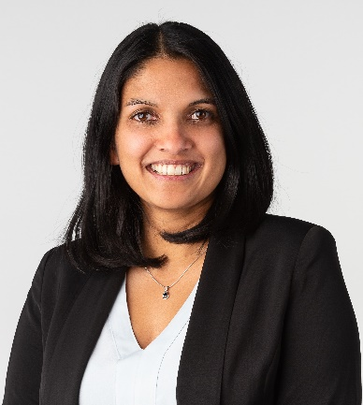
Gowri Pincombe, BEng(Hons), PGDip
Senior Bridge Engineer at SMEC (Member of the Surbana Jurong Group)
Gowri completed her BEng (Hons) degree in Materials Engineering with Management at Imperial College, London, and also completed a post graduate diploma in Environmental Policymaking in an International Context at the Open University, London. Gowri has worked as a structural engineer delivering a range of building and bridge projects in the UK and Australia, including feasibility studies, detailed designs, tender design/documentation and Design & Build projects. Gowri has also pursued her passion for development work through her involvement in development projects in engineering and health sectors, in Sri Lanka, Uganda and South Africa. She was also the co-founder of two charities in the UK; ‘Jersey Asia Relief Appeal’ for providing emergency relief to communities affected by the 2004 Boxing Day Tsunami, and ‘Jersey Side by Side’ for providing assistance for post-disaster reconstruction projects. She is keen to further explore how the role of an engineer can impact the communities in need around the world. She is currently pursuing a Masters in International Development at the University of Canberra
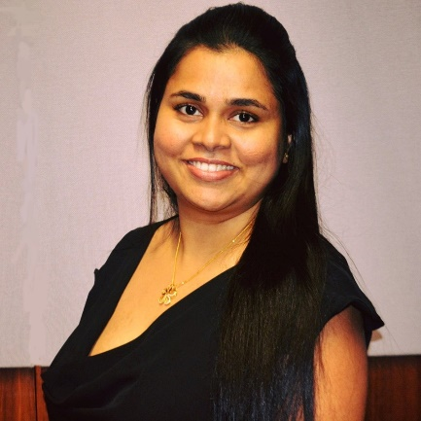
Chamindi Jayasuriya, BScEng(Hons)
Doctoral Student and Research Associate, University of Wollongong
Chamindi Jayasuriya is currently working as a Research Associate at the University of Wollongong (UOW), Australia. In 2013, she obtained her BSc in Civil Engineering from the University of Moratuwa. In 2014, Chamindi joined the Centre for Geomechanics and Railway Engineering (CGRE) at UOW to pursue her PhD in transport geotechnics. She was awarded the “Comprehensive Design Project Award in Civil Engineering for the best Civil Engineering student” and “Transportation Engineering Award “. In 2018, Chamindi won the “Young Geotechnical Engineer Best Paper Award” at the ISGTI held in Delhi, India, “Buddhima Indraratna Award for Industry Engagement”, IESL NSW Chapter “Engineering Excellence Award” in Best Paper Published Category and “Young Geotechnical Professionals Awards-Runner Up” (AGS). Her current research interests include railway engineering, energy absorbing materials and waste materials in geotechnical applications.
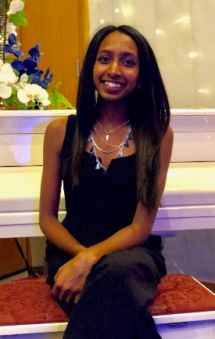
Naduni Obadage,
Chemical Engineering Student, University of New South Wales
Undergraduate Engineer at City Water Technology
Founding Secretary, Impact Engineers
Naduni is a fourth year Chemical Engineering student at UNSW working towards her BEng (Hons), with an interest in the water and wastewater engineering industry. She is currently working as an Undergraduate Engineer with City Water Technology. Naduni is focusing her honours thesis research on developing a guidance tool for better management and selection of water treatment technology. Naduni is the founding secretary of Impact Engineers, a student-led humanitarian engineering team of UNSW Engineering. Since its inception, she has been involved in multiple projects; delivering clean drinking water to Galwaduwagama - a village in Anuradhapura, Sri Lanka. She is now working on a project in Walgett, in conjunction with an indigenous community and their organisation –Dharriwaa Elders Group.
Navya Jayawardena,
Civil Engineering and Architecture Student, University of New South Wales
Navya Jayawardena is a third year student of Bachelor of Civil Engineering (Honours) with Architecture degree at the University of New South Wales. She is involved in the UNSW Women in Engineering and UNSW Engineers Without Borders Societies. She graduated from Baulkham Hills High School in 2016, achieving a place on the HSC All Rounders List.

