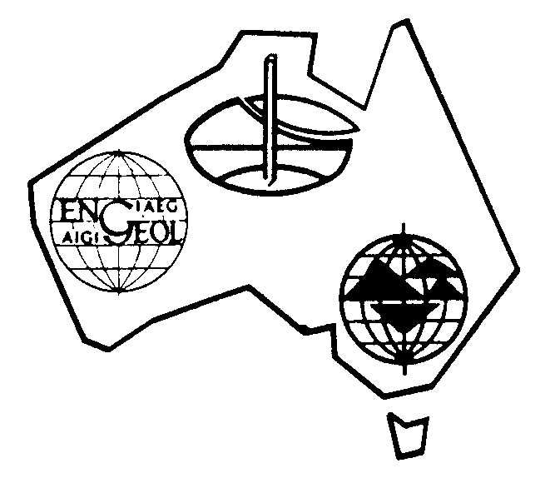

Australian Geomechanics Society

VICTORIA CHAPTER

LVGG Technical Meeting:

Landslides, Risk Concepts
and Case Studies

Presenter: | Anthony (Tony) Miner  Principal Geotechnical Engineer | A.S. Miner Geotechnical Consulting Engineers
Topic: | Landslides, Risk Concepts and Case Studies  The presentation includes an overview of landslide types, mechanisms and discusses the role of preparatory factors and triggering causes in landslide occurrence.  A brief history of Landslide Risk Management (LRM) in Australia is provided as background to a discussion of the Australian Geomechanics Society’s (AGS) 2000 and 2007 LRM Guidelines. A discussion of risk concepts and the AGS risk process is then provided with comment on implications for both regulators and practitioners.  Finally a series of case studies and examples are provided to highlight key issues.
Speaker Bio | Tony Miner graduated as a Civil Engineer from Deakin University in 1978 and later gained a Masters degree in engineering geology at the University of Ballarat. He has experience in a diverse range of projects in the geotechnical engineering and environmental fields and is currently Principal Geotechnical Engineer with A.S.Miner Geotechnical.  His focus over the past 15 years has been on risk management and landslides studies principally in the South Western Victoria area from the Bellarine Peninsula to Portland. He has also been involved with landslide studies, planning reviews and monitoring programs in Wollongong (NSW) and Tasmania.  He has contributed to erosion management and planning studies for several local authorities as part of the Corangamite Catchment Management Authority’s regional soil health strategy and was engaged to produce landslide and erosion inventories and regional susceptibility maps for the area which he has since helped to integrate into planning control overlays for the Otways and SW Victoria.  Tony is actively involved in landslide research through formal associations with both The University of Ballarat and The University of Wollongong and he has published a number of landslide and risk related conference papers. He was a member of the 2007 Australian Geomechanics Society’s NDMP Landslide Taskforce (for Landslide Risk Management) and a member of the working groups which prepared the ‘Guideline for Landslide Susceptibility, Hazard and Risk Zoning for Land Use Planning’ and ‘The Australian GeoGuides for Slope Management and Maintenance’.  Tony co-presented the AGS National Seminar Series on Landslide Risk Management in 2011 which was held in 9 state capitals and cities around Australia and was a key program developer and one of the main presenters for the AGS sponsored course “Field Techniques for Landslide Assessment” which was held in Melbourne in November 2014. He has also been recently invited to chair the upcoming AGS Technical Committee on Landslides.
Tuesday 13 October 2015
Time: 4:00pm (with light refreshments)

Where: Room 3W238 | Federation University Gippsland

Cost: $0 - Free, refreshments provided
Registrations: erica.matthews@federation.edu.au

PLEASE VISIT OUR WEBSITE: http://www.australiangeomechanics.org/

Attendance at this seminar contributes towards the EA’s requirements for Continuing Professional Development

Contact: Event Organiser: Erica Matthews 035122 8936
If you no longer wish to receive AGS emails please unsubscribe to secretary@australiangeomechanics.org

